**Python Assignment rollno:E0324003**

**“Analysis of Monthly Sales Performance of a Retail Store”**

**Dataset:**

| **Month** | **Sales (₹)** | **Profit (₹)** | **Customers** | **Advertisement Spend (₹)** |
| --- | --- | --- | --- | --- |
| Jan | 12000 | 2500 | 200 | 1500 |
| Feb | 15000 | 3000 | 240 | 1700 |
| Mar | 18000 | 3500 | 300 | 1900 |
| Apr | 22000 | 5000 | 400 | 2100 |
| May | 25000 | 6000 | 420 | 2500 |
| Jun | 20000 | 4500 | 390 | 2000 |
| Jul | 27000 | 6200 | 440 | 2600 |
| Aug | 30000 | 7000 | 480 | 3000 |
| Sep | 28000 | 6400 | 460 | 2800 |
| Oct | 35000 | 8000 | 500 | 3300 |
| Nov | 32000 | 7500 | 470 | 3100 |
| Dec | 40000 | 9500 | 550 | 4000 |

**1.Bar Graph – Monthly Sales Comparison**

**Code:**

import matplotlib.pyplot as plt

months = ["Jan","Feb","Mar","Apr","May","Jun","Jul","Aug","Sep","Oct","Nov","Dec"]

sales = [12000,15000,18000,22000,25000,20000,27000,30000,28000,35000,32000,40000]

plt.bar(months, sales, color='skyblue')

plt.title("Monthly Sales Comparison")

plt.xlabel("Months")

plt.ylabel("Sales (₹)")

plt.show()

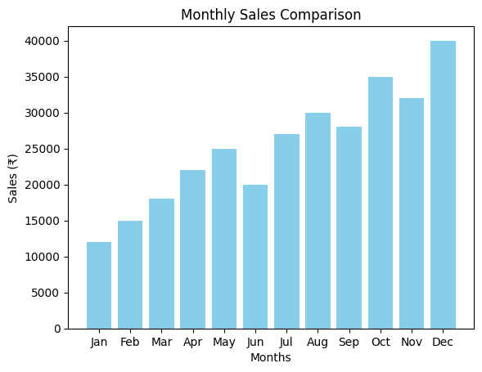

**Why use Bar Graph:**  
A bar graph is best for **comparing discrete categories** (months) side-by-side. It clearly shows which months performed better or worse in sales.

2.) **Pie Chart – Percentage Contribution of Each Month to Total Sales**

**import matplotlib.pyplot as plt**

**months = ["Jan","Feb","Mar","Apr","May","Jun","Jul","Aug","Sep","Oct","Nov","Dec"]**

**sales = [12000,15000,18000,22000,25000,20000,27000,30000,28000,35000,32000,40000]**

**plt.pie(sales, labels=months, autopct='%1.1f%%', startangle=90)**

**plt.title("Percentage Contribution to Annual Sales")**

**plt.show()**

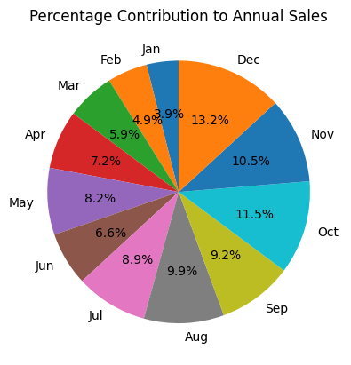

**Why use Pie Chart:**  
A pie chart is ideal for showing **proportional contribution** of each month to the total annual sales. It’s easy to see which month dominates overall sales.

**3. Histogram – Distribution of Profits**

profits = [2500,3000,3500,5000,6000,4500,6200,7000,6400,8000,7500,9500]

plt.hist(profits, bins=6, color='lightgreen', edgecolor='black')

plt.title("Profit Distribution")

plt.xlabel("Profit Range (₹)")

plt.ylabel("Frequency")

plt.show()

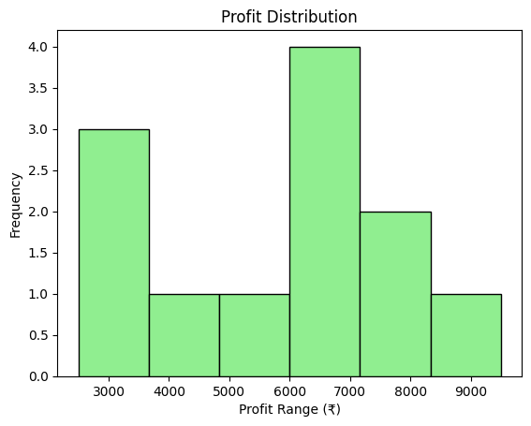

**Why use Histogram:**  
A histogram helps analyze the **distribution of continuous data** (like profit values) — showing how often profits fall in certain ranges

**4. Line Plot – Relationship Between Advertisement Spend and Sales**

ad_spend = [1500,1700,1900,2100,2500,2000,2600,3000,2800,3300,3100,4000]

plt.plot(ad_spend, sales, marker='o', linestyle='-', color='orange')

plt.title("Relationship Between Advertisement Spend and Sales")

plt.xlabel("Advertisement Spend (₹)")

plt.ylabel("Sales (₹)")

plt.show()

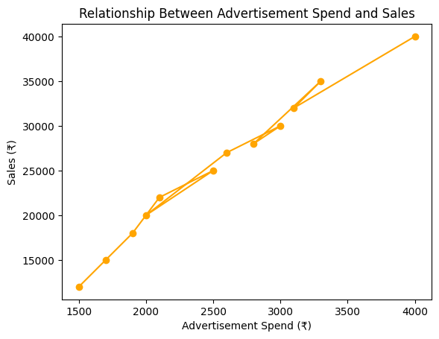

**Why use Line Plot:**  
A line plot is perfect for showing **trends or relationships** between two continuous variables (how ad spend affects sales).

**5. Scatter Plot – Sales vs Customers**

customers = [200,240,300,400,420,390,440,480,460,500,470,550]

plt.scatter(customers, sales, color='red')

plt.title("Sales vs Number of Customers")

plt.xlabel("Customers")

plt.ylabel("Sales (₹)")

plt.show()

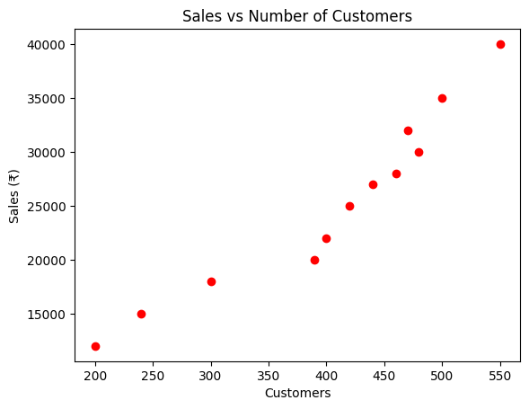

**Why use Scatter Plot:**  
Scatter plots are best to study **correlation** between two numerical variables — here, as customers increase, sales also rise.